TUGAS PEMROGRAMAN 1
PERTEMUAN 8

NAMA : MUHAMMAD REZZA KUSUMA
NIM : 241011402029
KELAS : 04 TPLP 011

- Flow Chart
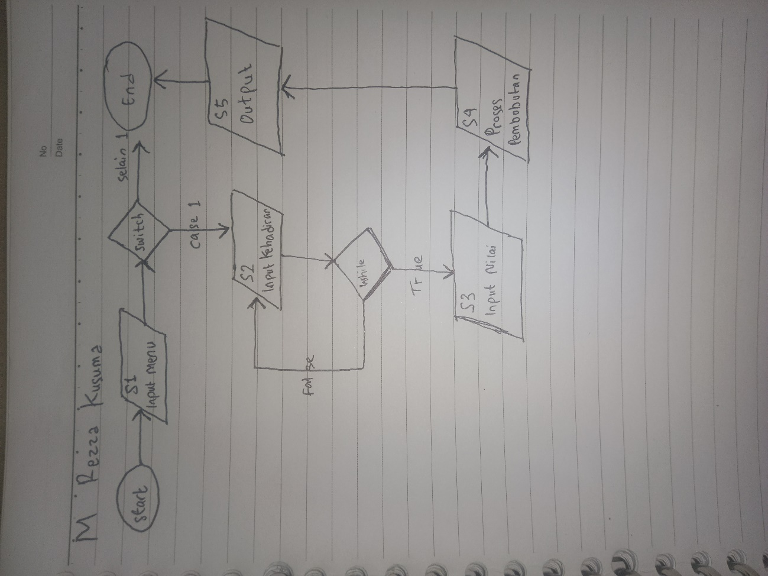
- Source Code
- package tugas;

- import java.util.Scanner;

- public class tugas2dev {
- public static void main(String args[]) {
- Scanner input = new Scanner(System.in);

- int menu;

- System.out.println("===== MENU =====");
- System.out.println("1. Hitung Nilai Mahasiswa");
- System.out.print("Pilih menu: ");
- menu = input.nextInt();

- switch (menu) {
- case 1:
- float kehadiran;
- float realisasi;
- float tugas, uts, uas;
- float nilaiKehadiran, nilaiTugas, nilaiUTS, nilaiUAS, nilaiAkhir;

- System.out.println("\n===== INPUT DATA =====");

- while (true) {
- System.out.print("Input jumlah kehadiran: ");
- kehadiran = input.nextFloat();

- System.out.print("Input realisasi pertemuan: ");
- realisasi = input.nextFloat();

- if (kehadiran >= 0 && kehadiran <= realisasi) {
- break;
- } else {
- System.out.println("Kehadiran tidak valid! Harus antara 0 - " + realisasi);
- }
- }

- System.out.print("Input nilai tugas: ");
- tugas = input.nextFloat();

- System.out.print("Input nilai UTS: ");
- uts = input.nextFloat();

- System.out.print("Input nilai UAS: ");
- uas = input.nextFloat();

- System.out.println("\n===== PROSES NILAI =====");

- nilaiKehadiran = (kehadiran / realisasi) * 10;
- nilaiTugas = tugas * 0.20f;
- nilaiUTS = uts * 0.30f;
- nilaiUAS = uas * 0.40f;

- nilaiAkhir = nilaiKehadiran + nilaiTugas + nilaiUTS + nilaiUAS;

- System.out.println("\n===== HASIL =====");
- System.out.println("Nilai Kehadiran : " + nilaiKehadiran);
- System.out.println("Nilai Tugas : " + nilaiTugas);
- System.out.println("Nilai UTS : " + nilaiUTS);
- System.out.println("Nilai UAS : " + nilaiUAS);
- System.out.println("--------------------------");
- System.out.println("Nilai Akhir : " + nilaiAkhir);

- break;

- default:
- System.out.println("Menu tidak tersedia");
- }

- input.close();
- }

- }

- Output
===== MENU =====
1. Hitung Nilai Mahasiswa
Pilih menu: 1

===== INPUT DATA =====
Input jumlah kehadiran: 21
Input realisasi pertemuan: 21
Input nilai tugas: 70
Input nilai UTS: 80
Input nilai UAS: 90

===== PROSES NILAI =====

===== HASIL =====
Nilai Kehadiran : 10.0
Nilai Tugas : 14.0
Nilai UTS : 24.0
Nilai UAS : 36.0
--------------------------
Nilai Akhir : 84.0

